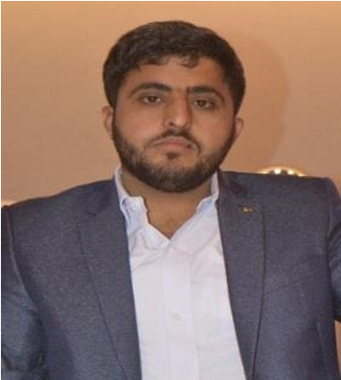
OBJECTIVE:

Aqeel

Khan

Address:
CMT&SD Golrha Flats,
Rawalpindi.

Contact

No:

03058686453

Email:

hiaqeelkhan@gmail.com

- Motivated and enthusiastic learner, eager to absorb and acquire new skills.
- To make use of my skills so developed to achieve goals of a company that focuses on customer satisfaction and experience.

EDUCATION:

BS CS (Last Semester) | Federal Urdu University (FUUAST), Islamabad
ICS | FBISE, Islamabad
Matric (Science) | BISE, D.I.Khan

PRIOR EXPERIENCE:
- InnoTech Solutions Pvt Ltd (4 x months)
- Two Project Complete in University

SKILLS:
- React Js
- Node Js
- Python
- HTML,CSS
- C++
- Java

PERSONAL INFORMATION:

Father Name | Abdul Latif Khan
Date of Birth | 07.06.2003
CNIC No | 12102-9120084-1
Gender | Male
Nationality | Pakistani
Religion | Islam

LANGUAGES:
- English
- Urdu
- Pashto

